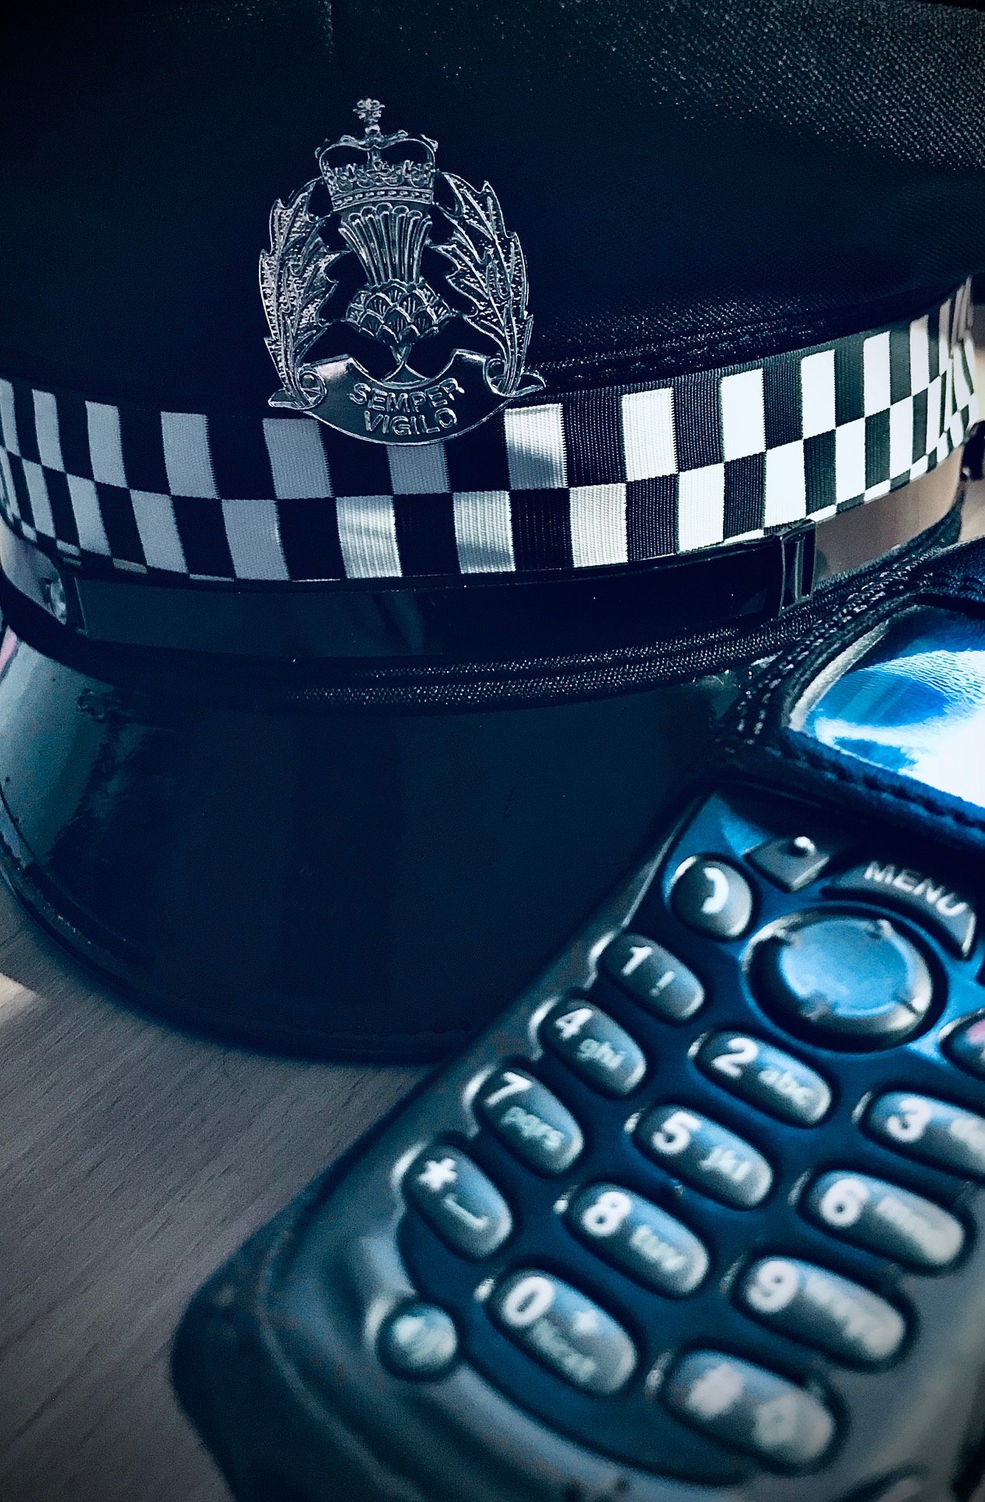
  - reducing the misery caused by drugs
With well over a 1000 drugs deaths in Scotland annually, it is an absolute priority to do everything we can to reduce this dreadful statistic and the misery caused to families by the death of a loved one.

sPECIAL bULLETIN – DRUG DEALING

working with our communities to tackle drug dealing
  - reducing the misery caused by drugs
  - FACTS
- £405,000.00 worth of drugs recovered

- £161,000.00 in cash seized

- £65,000 worth of property seized that had been
purchased through proceeds of crime
www.crimestoppers-uk.org or 550800 555 11

I’m often asked WHAT ARE YOU DOING ABOUT IT? I often respond WHAT ARE YOU DOING ABOUT IT?
Let me explain, for Police to take action against drug dealers (enter buildings/vehicles etc.) we need to have a warrant issued by a sheriff. To get this warrant we have to present credible and recent intelligence which details why we think it’s necessary. WE GET THIS INFORMATION FROM OUR COMMUNITIES.
We want to execute warrants and deal with drug dealers, but we need the information. Quite often people will talk about it without going to the next level of picking up the phone to Crimestoppers.
The drug dealers are ruthless, they care not a jot about the carnage they create and maintain power through fear. In actual fact I believe that “we” as a community have the power and ability to identify and deal with them effectively.
So what have we (all) achieved?
West Lothian Pro-Active Unit have been targeting organised crime groups. Through the use of intelligence, the unit identify targets who are involved and profit from the supply of controlled drugs. In the last 6 months the unit have recovered £405,000.00 worth of drugs, £161,000.00 in cash and have seized approximately £65,000.00 worth of property that had been purchased through illegal proceeds of crime.
However, now more than ever, we require further information in regards to persons believed to be involved in criminal activity. You can do this anonymously via Crimestoppers at www.crimestoppers-uk.org or 0800 555 111.
Please encourage everyone to join the fight against drugs.
Community Sergeant Jack

